Chapter 1 Start developing App with MIT App Inventor 2

Key Words
Online Platform 網上平台 | Component 元件 / App 中的物件 | Visible 可視的
Non-visible 不可視的 | Interface 界面 / 程式畫面
Notes
- Create a project in online platform: App Inventor 2

- Step 1: Open URL: http://ai2.appinventor.mit.edu/ in Google Chrome.
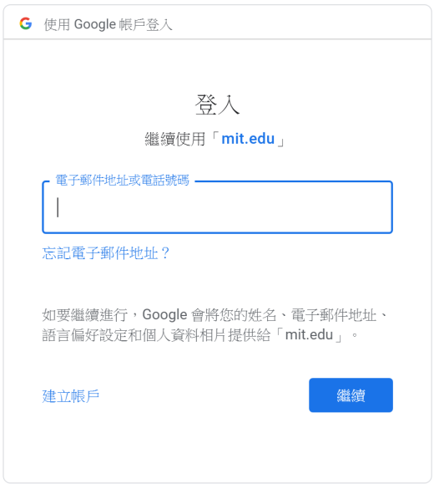

- Step 2: Login with Google (Use your school Google account).

- Step 3: Add a new project:
Select "My Projects" "Start new project"
or
Click the button "Start new project"
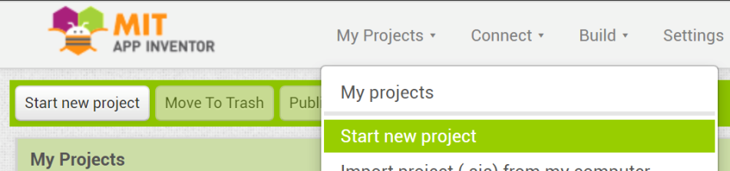

*** You should enter a name,
(i) begin with a letter,
(ii) contain no spaces,
(iii) only contain letters, numbers and underscores.
- Step 4: You may now start developing your first App.
Notes
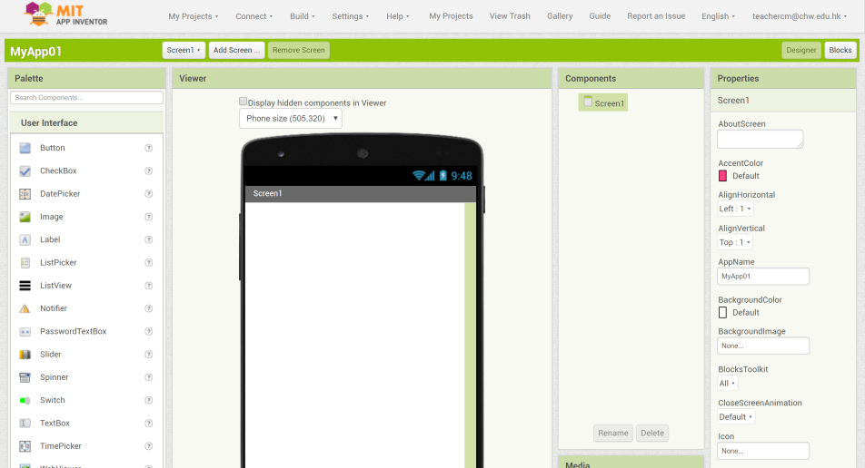

- Introduction to five common components
Examples of visible component:
- User Interface Buttons – It is used to detect click.
- User Interface Image – It is used to display image/picture.
- User Interface Label – It is used to show text.
- User Interface TextBox – It is used for user text input.

Example of non-visible component:
- Sensors Clock – It is used to fire a timer to perform specific task.
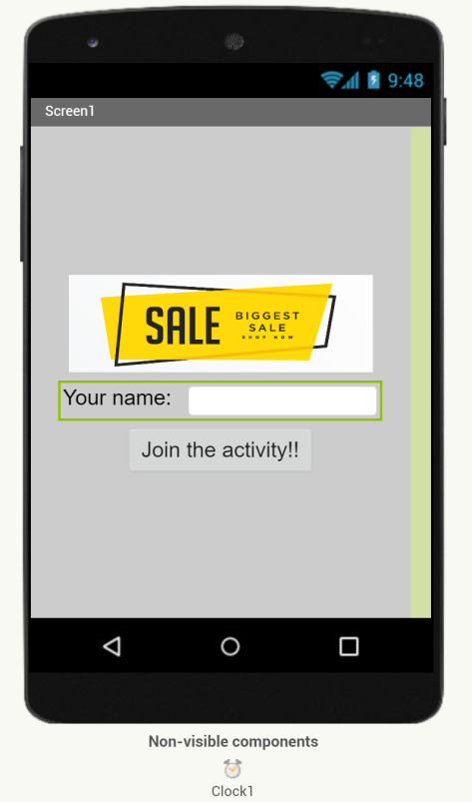
Image
Textbox
Button
Label
Clock
Screen
Example of an user interface
- Homework

Task 1:
- Finish "Worksheet 01". Name the component in the interfaces given.
- Scan you homework into PDF format and submit to the Schoology.
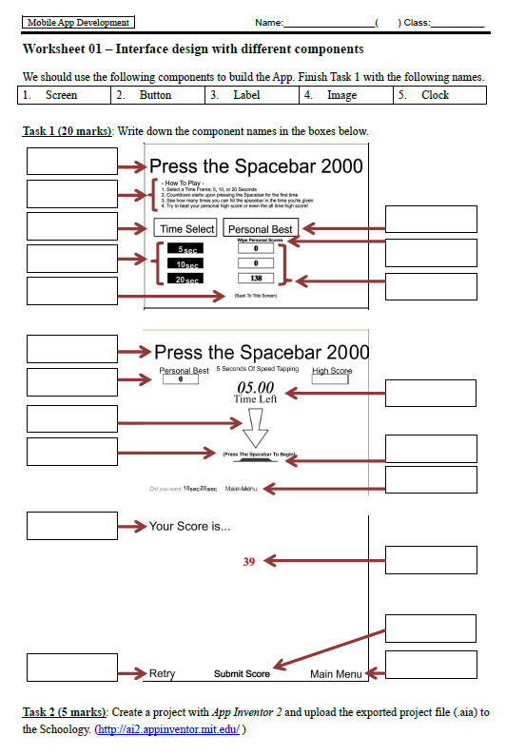
Worksheet 01

Task 2:
- Login MIT App Inventor 2 (http://ai2.appinventor.mit.edu).
- Start a new project.
- Add some components on Screen1. E.g. Image, Label, Textbox, Button, …
- Export the project into (.aia) format and submit to the Schoology.

第 2 章 設計應用程式的界面
Notes
- 開發應用程式的第一步：新增畫面
- 預設情況下，畫面「Screen1」應該是啟動畫面。
- 你應該通過新增所需的畫面來設計應用程式的結構。
- 例如，新增一個畫面「Game」。
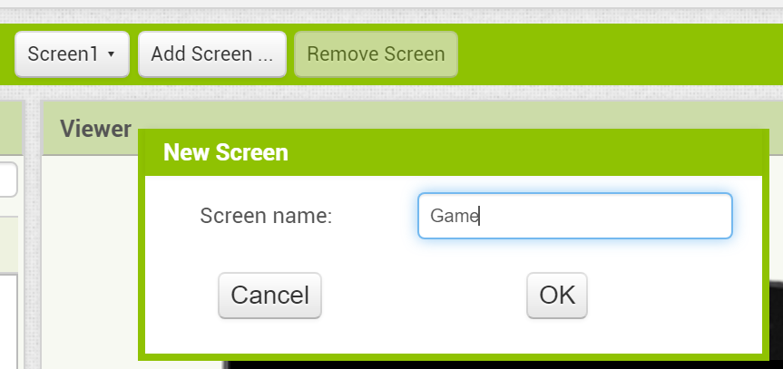

- 在新增兩個畫面「Game」和「Result」後，下圖顯示了一個包含 3 個畫面的應用程式。
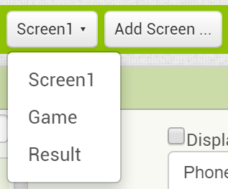

- 開發應用程式的第二步：界面設計
- 你應該設計每個畫面的界面。
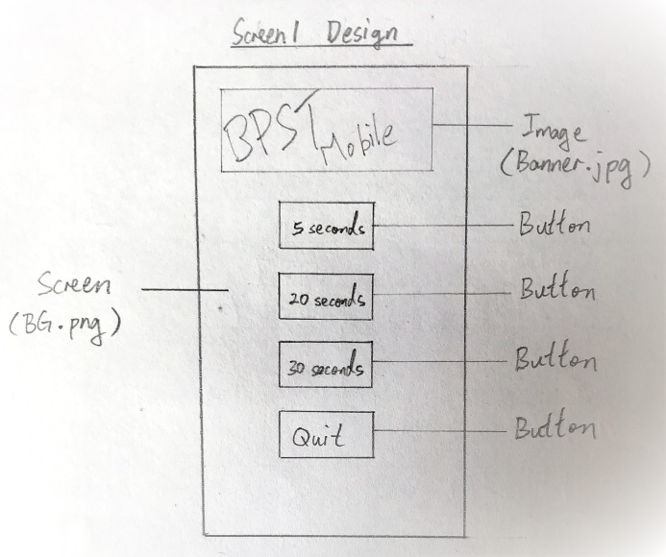
An example of the Main Menu interface design
Notes
- 設計界面時，應考慮以下幾點：

- 界面的佈局（Layout）；
- 畫面上所需的元件；
- 每個元件的屬性（Properties）

Layout – The way in which text or pictures are set out on a screen.
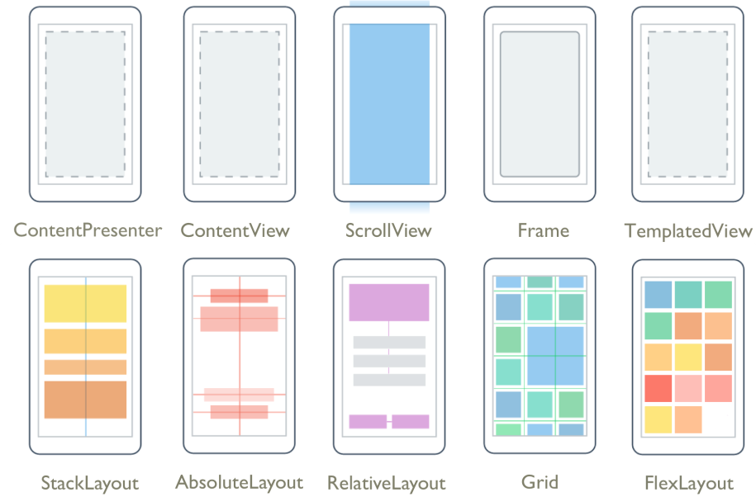
Image source: https://docs.microsoft.com/zh-tw/xamarin/xamarin-forms/user-interface/controls/layouts

- In App Inventor 2, there are several types of layout component.
Notes
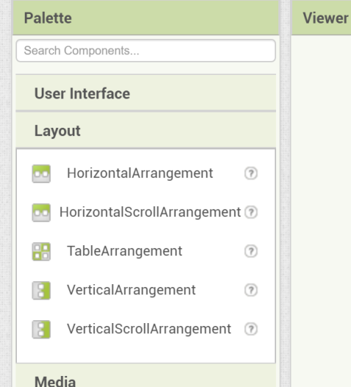

- Layout HorizontalArrangement or
Layout HorizontalScrollArrangement
- Arrange objects from left to right
(non-scrollable or scrollable)
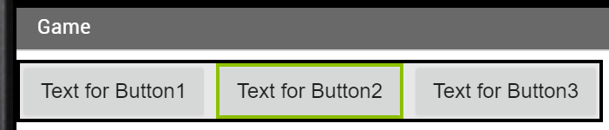

- Layout VerticalArrangement or
Layout VerticalScrollArrangement
- Arrange objects from top to bottom
(non-scrollable or scrollable)
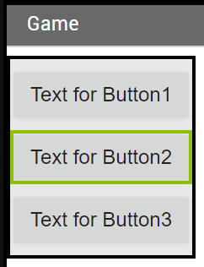

- Layout TableArrangement
- Array objects in grid form
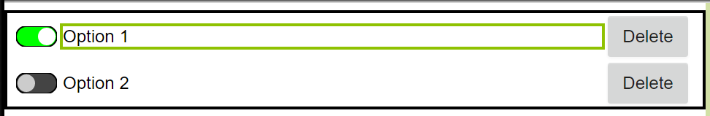

Components – the objects in an App.
Notes

(Reference: http://ai2.appinventor.mit.edu/reference/components/)

- The following table shows some components in the categories "User Interface" and "Layout". (You can refer the reference site above to see the full list of components and their functions)
User Inteface | Layout
Button  CheckBox  Image  Label  PasswordTextBox  Screen  Switch  TextBox | HorizontalArrangement  HorizontalScrollArrangement  TableArrangement  VerticalArrangement  VerticalScrollArrangement

Properties – The values of the properties represent the state of the component.

- E.g. Button.Text = "Happy"
It means that the text "Happy" shows on the button.
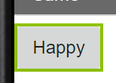

- E.g. Label1.BackgroundColor = Red
It means that set the background color of Label1 to red.

- E.g. Label1.FontSize = 20
It means that set the font size of text on Label1 to point 20.
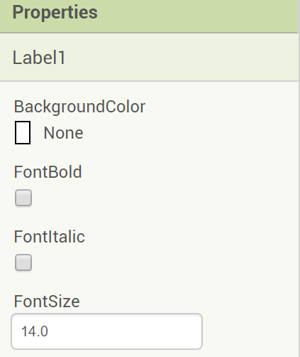

Add component to the Screen and change its properties.
Notes
- Add components into every screen by dragging components into screens.
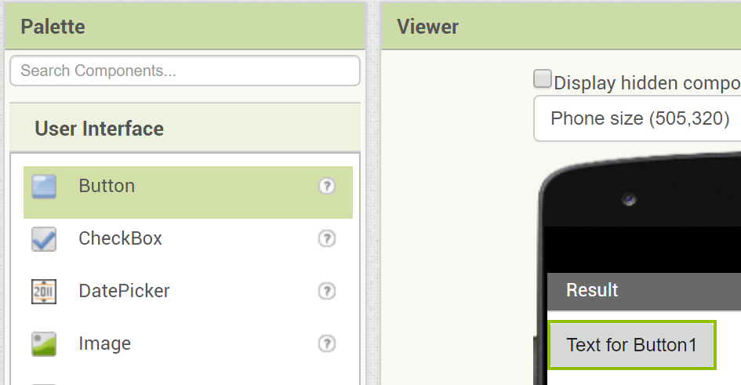
Drag

- Select the component and change its properties by changing the values in the properties window (at the right-most area).
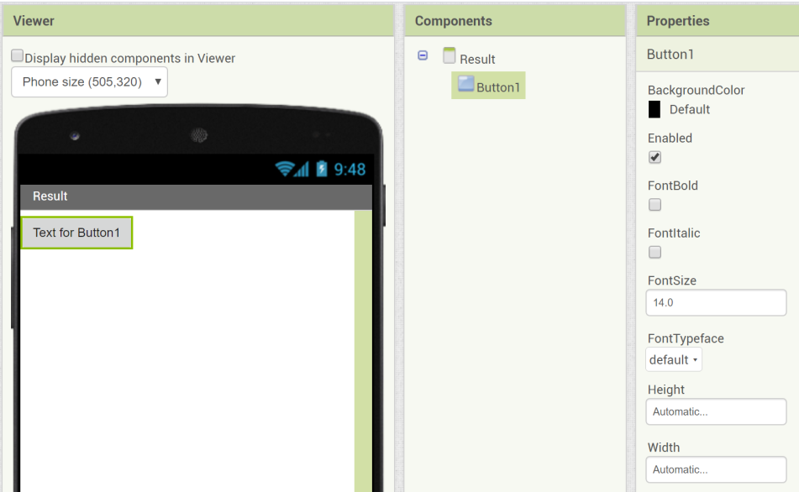

- The following is the introduction of some common properties.
  - BackgroundColor – It indicates the color of the component.
  - Enabled – It indicates user can use this component or not.
  - FontSize – It indicates the size of text on the component.
  - Height – It indicates the height of the component.
  - Width – It indicates the width of the component.
  - Text – It indicates the text shown on the component.
  - Visible – It indicates the component can be seen or not.

- You can find all properties introduction of components in the web-site (http://ai2.appinventor.mit.edu/reference/components/).

- Homework

Task 1 (10 marks):
You are a mobile App developer. Before program the App "Button Pressing Speedtest (BPST Mobile)" in App Inventor 2, you should design 3 interfaces (Screen1, Game, Result) by

- Sketching the layout and components on each screen.
- Name the components on each screen.

You should design the interfaces "Game" and "Result" by drawing.

Task 2 (5 marks):
In MIT App Inventor 2, finish the following steps:

Step 1: Start a new project named "BPST_3201". (Please use your own class and class number)
Step 2: Use "Add Screen…" function to add 2 screens named "Game" and "Result".
Step 3: In every screen, try adding components according to your design in Task 1 and design the interface "Screen1" as well.
Step 4: Try to edit the "Properties" of every components.
Step 5: Export your project to (.aia), and submit to the Schoology.

Chapter 3 Add programming code (blocks) in an App

Key Words
Designer mode 界面設計模式 | Blocks mode 編程模式 | Behaviour 行為表現
Event （觸發）事件 | Program Log 程式日誌

- Third step of developing App: Add programming code (Blocks)
Notes
- There are two modes in MIT App Inventor 2: "Designer mode" and "Blocks Mode".

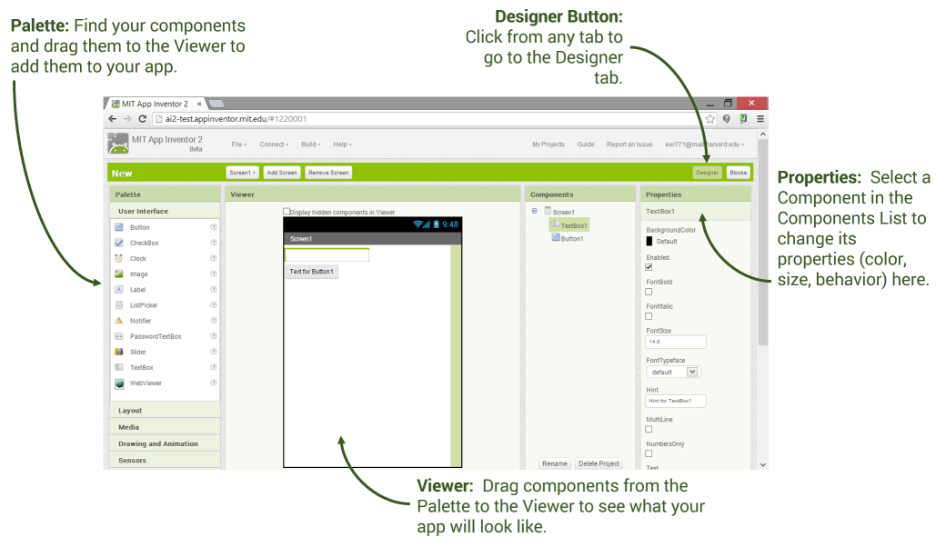
Designer Mode

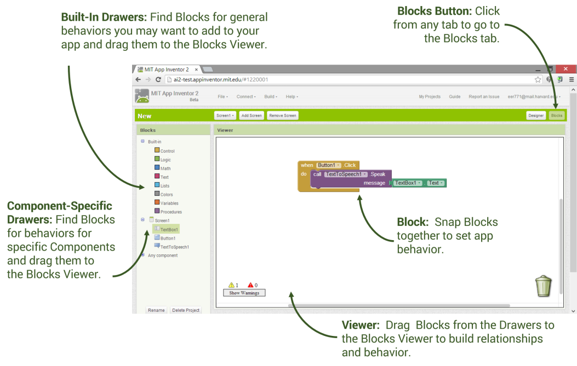
Blocks Mode
- There are two buttons "Designer" and "Blocks" at the top-right hand corner. They are used to switch between "Designer Mode" and "Blocks Mode" respectively.
Notes
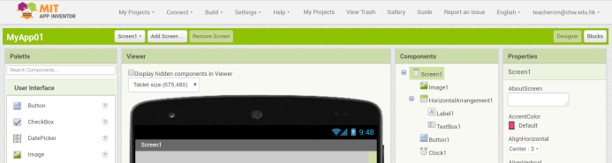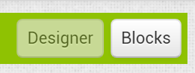

- Designer Mode – In this mode, you can:
  - Add screens;
  - Set the layout of the interface;
  - Add components;
  - Change the properties.

- Blocks Mode – In this mode, you can add the programming code (Blocks) to control the behaviour of the App.
For example:

  - When the component "Button1" is clicked,
the text of the "Label1" will change to "Happy".
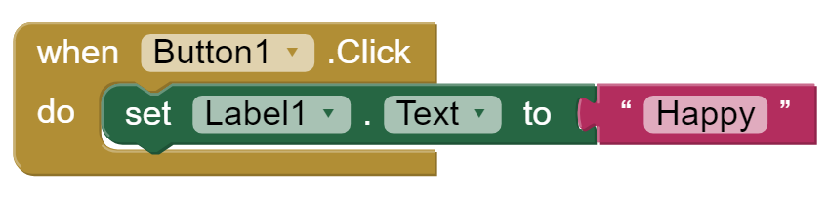

The following figure shows the effect of the above blocks.
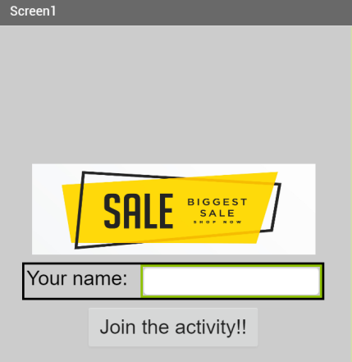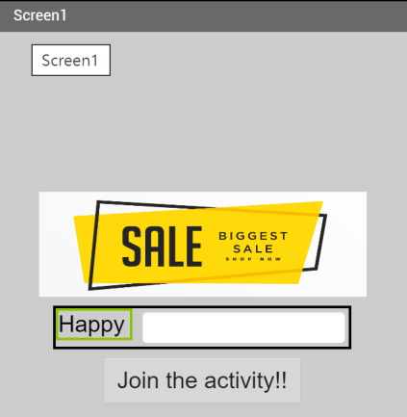
Click

  - When the component "Button1" is clicked,
another screen named "Screen2" will be opened with a starting value 1000.
Notes
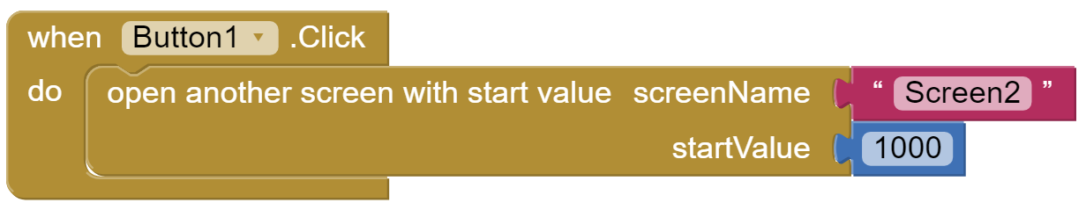

The following figure shows the effect of the above blocks.
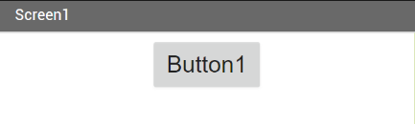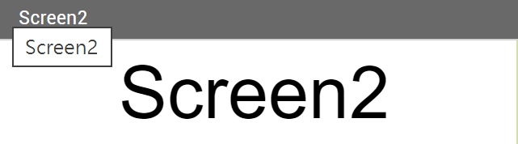
Click

  - When the component "Button1" is clicked,
the text of "Label1" will be increased by 10.
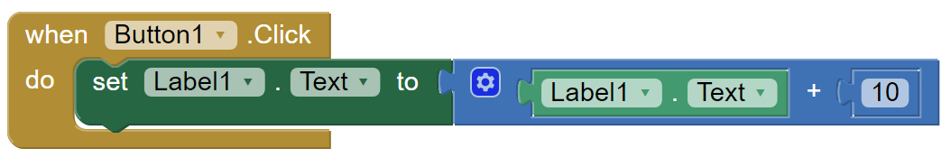

The following figure shows the effect of the above blocks.
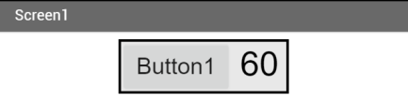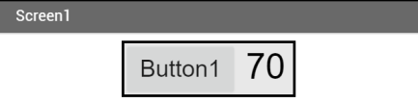
Click

- Besides the event "Click" of a button, there are many other events of different components. Please check the following reference links to learn more.


http://ai2.appinventor.mit.edu/reference/blocks/


http://ai2.appinventor.mit.edu/reference/components/index.html
- Homework

Task 1 (5 marks): - Adding blocks.
In MIT App Inventor 2, finish the following steps:

Step 1: Open the project "BPST_2E01", which was built in last week.

Step 2: Make sure that you have finished all interfaces design (Designer Mode).

Step 3: Add blocks to do the following (Blocks Mode).

- To control the screen changing.
- To update the count shown on the Label when the user clicks on the button.

Step 4: Export your project to a file (.aia) and submit to the Schoology.

Task 2 (5 marks): - Keeping program log.
Please copy the programming code from your project. You should keep the log in a systematic way. Therefore, in the spaces provided below, please write down the blocks that you have used in different screens. An example in "Screen1" is shown below.

Screen "Screen1"
When Button1.Click
do open another screen with start value screenName "Game"
startValue 0

Please keep your program log in "Worksheet 03".

Chapter 4 Add programming code (blocks) in an App

Key Words
Fire 觸發 | Interval 間距 | Non-visible 不可視的
Countdown 倒數 | Program Log 程式日誌

- Introduction to "Sensors Clock"
Notes
- It provides the system date and time using the internal clock on the phone.
- It can fire a timer at regularly set intervals.

An example of using "Sensors Clock" – A timer program.

Step 1: Add the component "Sensors Clock"
- You can add "Sensors Clock" to the screen by dragging the clock to the screen.
- The clock will be added as a non-visible component.
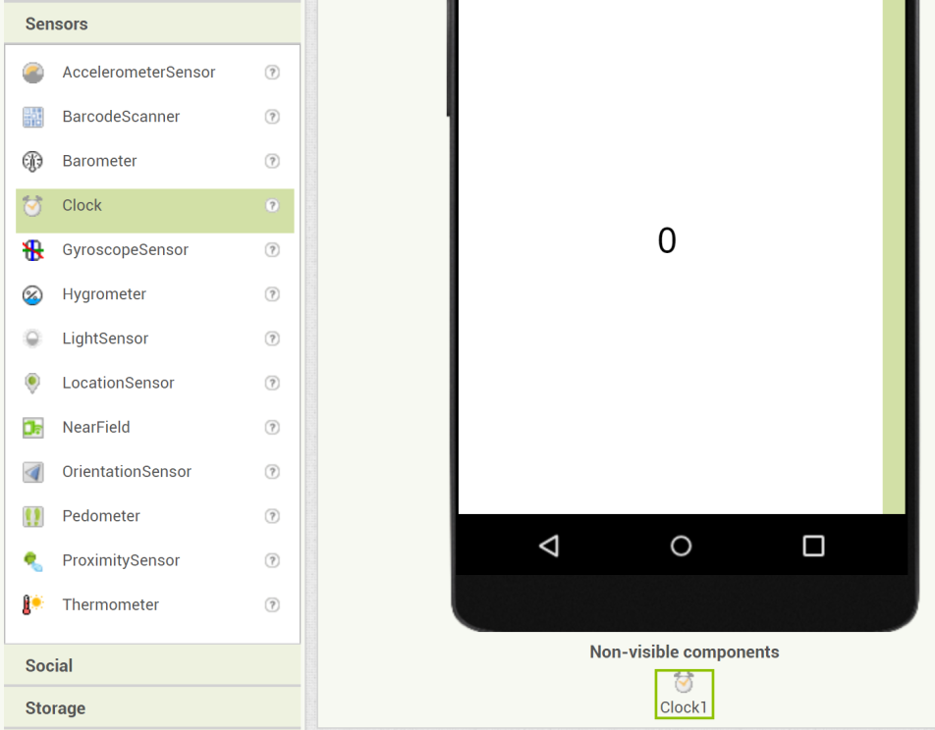
Drag

Step 2: Change the properties of the clock
Notes
- The properties "TimerEnabled" specifies whether the Timer event should run, its value can be "True" or "False".
- The properties "TimerInterval" specifies how long the clock will fire the Timer event.
- TimerInterval:
  - TimerInterval = 1000 1 second
  - TimerInterval = 500 0.5 seconds
  - TimerInterval = 3000 3 seconds
  - If we want to perform a task 10 times in a second, the TimerInterval = 1000 / 10 = 100
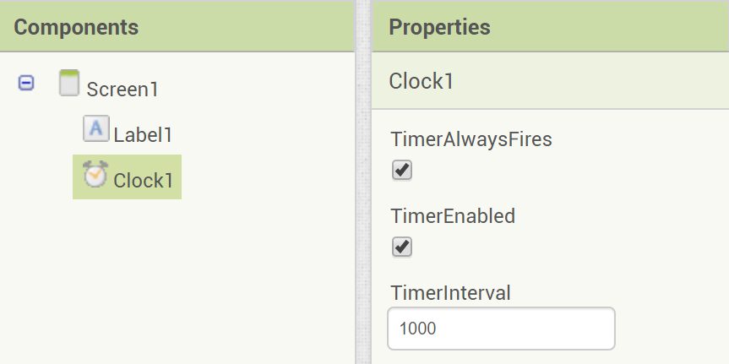

Step 3: Add blocks to the clock
- You can add blocks in the event "When Clock1.Timer do …".
- For example, we add the value of Label1.Text by 1 every "TimerInterval" (1000 ms).
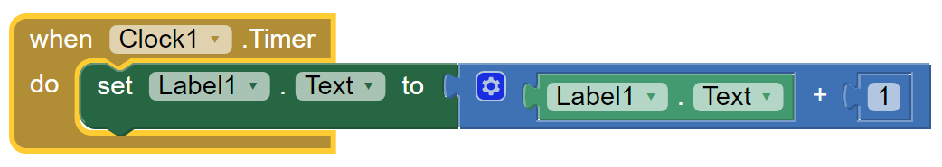

- Homework

Task 1 (5 marks): - Adding the countdown feature to the game.
In MIT App Inventor 2, finish the following steps:

Step 1: Open the project "BPST_2E01", which was built in last week.

Step 2: Make sure that you have finished all interfaces design (Designer Mode).

- Add a component "Sensors Clock" to the screen "Game".

Step 3: Add blocks to do the following (Blocks Mode).

- To control the countdown with "Sensors Clock".
- To display the time left with Label..

Step 4: Export your project to a file (.aia) and submit to the Schoology.

Task 2 (5 marks): - Keeping program log.
Please copy the programming code from your project. You should keep the log in a systematic way. Therefore, in the spaces provided below, please write down the blocks that you have used in different screens. An example in "Screen1" is shown below.

Screen "Screen1"
When Button1.Click
do open another screen with start value screenName "Game"
startValue 0

Please keep your program log in "Worksheet 04".

Chapter 5 Add images and background music in an App

Key Words
Upload 上載 | Source 來源

- Adding images
Notes
- You can upload background image to the screen "Screen1" by editing the property: "Screen1.BackgroundImage".
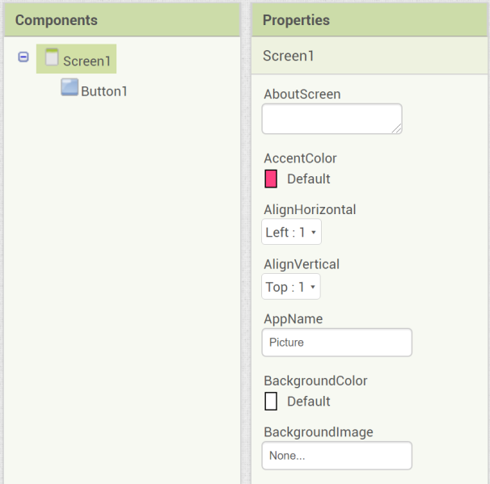

- You can change the image of the component "Button1" by editing the property: "Button1.Image".
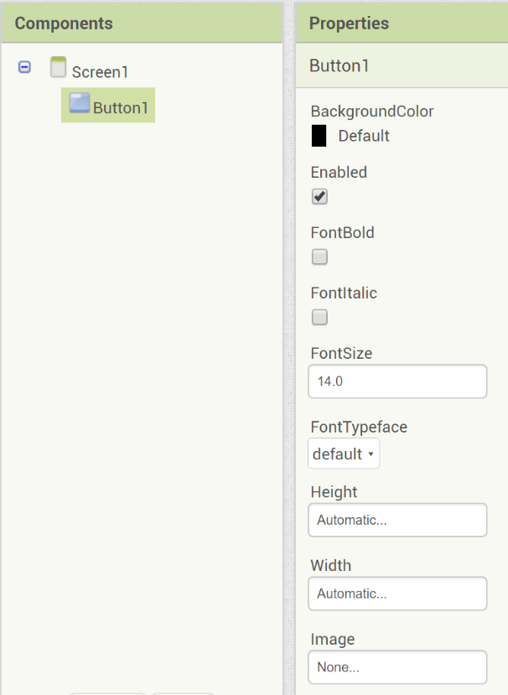

- Adding background music
Notes
- You should add a component "Media Player" to the screen.
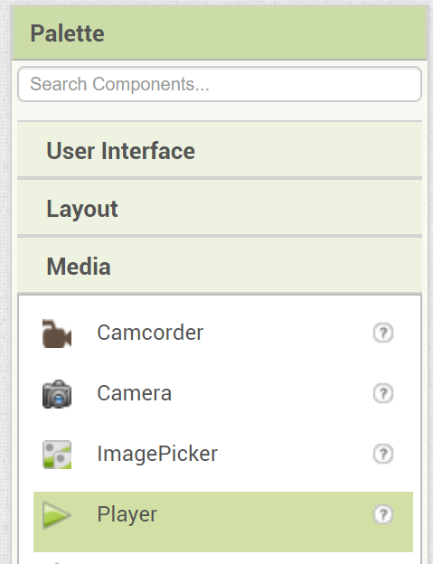
- You can upload a MP3 music file to the component "Player1" by editing the property "Player1.Source".
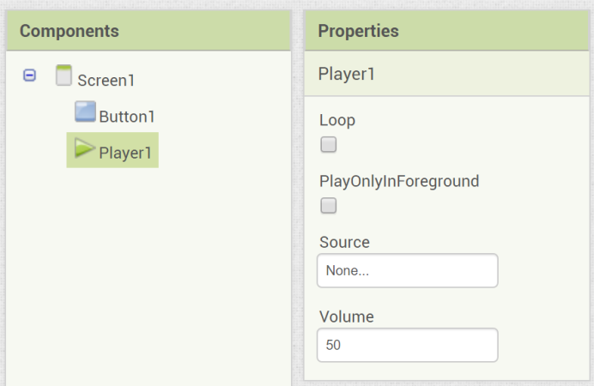

- Properties of the component "Player":
  - Player1.Loop
If checked (value True), the music will be played again after finish.

  - Player1.PlayOnlyInForeground
If checked (value True), the music will stop when leaving the current screen.

  - Player1.Source
Upload or change the music file source.

  - Player1.Volume
Control the loudness of the music in terms of percentage (0 to 100)
- Start playing the background music in Block mode.
Notes
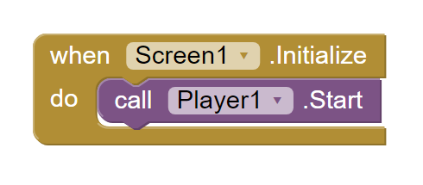

- Homework

Task 1 (10 marks): - Adding the images and background music to the game.
In MIT App Inventor 2, finish the following steps:

Step 1: Open the project "BPST_2E01", which was built in last week.

Step 2: Make sure that you have added background image to every screen.
And change the image of every button

Step 3: Add blocks to do the following (Blocks Mode).

- To start and stop the background music.

Step 4: Export your project to a file (.aia) and submit to the Schoology.

Online Platform 網上平台
Component 元件 / App 中的物件
Visible 可視的
Non-visible 不可視的
Interface 界面 / 程式畫面
Scrollable 可捲動
Grid 格 / 格子
Designer mode 界面設計模式
Blocks mode 編程模式
Behaviour 行為表現
Event （觸發）事件
Program Log 程式日誌
Fire 觸發
Interval 間距
Non-visible 不可視的
Countdown 倒數
Program Log 程式日誌
Upload 上載
Source 來源

